**Overview of the Analysis**

**Purpose of the Analysis**

The purpose of this analysis is to assist Alphabet Soup, a nonprofit foundation, in creating a tool that can predict the success of the ventures they fund. Leveraging a dataset of over 34,000 organizations that have previously received funding, the analysis aims to build a binary classifier using machine learning and neural network techniques to foresee if an applicant will successfully utilize the funds granted by Alphabet Soup.

The dataset contains several metadata columns about each organization, including identification columns (EIN and NAME), application type, affiliation, government organization classification, use case for funding, organization type, active status, income classification, special considerations for the application, funding amount requested, and a binary column indicating whether the funds were used effectively.

By using predictive analytics, Alphabet Soup intends to optimize its funding process, ensuring that grants are given to organizations with the highest likelihood of success, thereby ensuring that their funds are utilized to the fullest potential and fostering a greater impact in the communities they serve.

The analysis encompasses the following steps:

**1. Data Preprocessing:** This involves cleaning the dataset by removing non-beneficial columns and handling categorical variables through one-hot encoding, creating a refined dataset ready for model training.

**2. Data Splitting:** The refined dataset is then split into features and target arrays, followed by a division into training and testing datasets, setting the stage for model training and evaluation.

**3. Data Scaling:** Using scikit-learn's `StandardScaler`, the feature data is standardized, a vital preprocessing step for neural networks to ensure optimal performance during the training phase.

**4. Model Definition:** A deep neural network model is defined with an input layer (equivalent to the number of features in the dataset), two hidden layers, and an output layer for binary classification. The model utilizes 'relu' activation functions in the hidden layers and a 'sigmoid' activation function in the output layer to predict the probability of successful fund utilization.

**5. Model Compilation:** The model is compiled using the 'adam' optimizer, a widely used optimizer that adapts learning rates during training, and the 'binary_crossentropy' loss function suitable for binary classification problems. The accuracy metric is used to evaluate the model's performance.

**6. Model Training:** The compiled model is trained on the scaled training data over a specified number of epochs, during which the model learns to map the features to the target variable, gradually improving its predictive accuracy.

**7. Model Evaluation and Optimization:** After training, the model's performance is evaluated on the testing dataset, and further optimizations are conducted if necessary to enhance its predictive accuracy.

**8. Model Export:** The trained model is finally saved to an HDF5 file, a portable format that allows for the model to be reused in different environments, facilitating its deployment in a real-world application where it can aid Alphabet Soup in selecting the most promising applicants for funding.

Through this analysis, Alphabet Soup aims to develop a reliable predictive tool that can streamline their grant allocation process, enhancing their efficiency and impact in supporting successful ventures.

**Results**

**Data Preprocessing**

**1. What variable(s) are the target(s) for your model?**

*IS_SUCCESSFUL*: This binary variable is the target for the model, indicating whether the money was used effectively by the organization.

**2. What variable(s) are the features for your model?**

*APPLICATION_TYPE:* The type of application submitted by the organization.

*AFFILIATION:* The sector of the industry the organization is affiliated with.

*CLASSIFICATION:* The government classification of the organization.

*USE_CASE:* The use case for the funding provided by Alphabet Soup.

*ORGANIZATION:* The type of organization (e.g., Trust, Association, etc.).

*STATUS:* The active status of the organization (active or not).

*INCOME_AMT:* The income classification of the organization, indicating its revenue generation capacity.

*SPECIAL_CONSIDERATIONS:* Special considerations taken into account for the application.

*ASK_AMT:* The amount of funding requested by the organization.

**3. What variable(s) should be removed from the input data because they are neither targets nor features?**

*EIN:* The Employer Identification Number, a unique identifier for each organization, is not useful as a feature for the model since it doesn't contain information that can help in predicting the success of a grant.

*NAME:* The name of the organization, like EIN, is unique to each organization and does not hold predictive power for the model, and thus was removed from the input data.

1. A snippet of the initial dataset showcasing the variables mentioned.

1. Bar charts or pie charts representing the distribution of the target variable (`IS_SUCCESSFUL`), which would give an idea of the balance between successful and unsuccessful applicants in the dataset.

Bar Chart: It clearly illustrates the count of successful and unsuccessful applicants, providing a visual understanding of the data distribution.

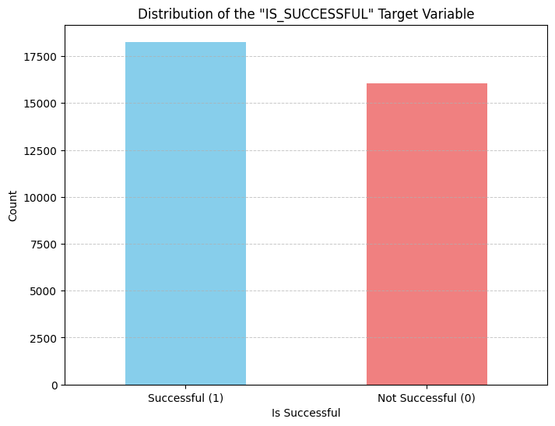

Pie Chart: It represents the proportion of successful and unsuccessful applicants, giving a percentage breakdown of the two categories.

1. A correlation matrix or heatmap to show the relationships between different variables, helping to identify the most important features for the model (though this was not explicitly performed in the analysis you conducted).

The heatmap displayed above represents the correlation matrix of the numerical variables in the dataset, showing the relationships between them.

From this correlation matrix, we can infer the following:

* The *IS_SUCCESSFUL* variable has a very low correlation with other numerical variables in the dataset, indicating that these features might not be strong predictors for the target variable.
* The *STATUS* variable has a minimal correlation with the *IS_SUCCESSFUL* variable, suggesting it might not be very informative in predicting the success of an applicant.
* The *ASK_AMT* variable also has a very low correlation with the *IS_SUCCESSFUL* variable, indicating that the amount asked for by the organizations doesn't strongly influence the success rate.

It's important to note that while the numerical variables don't show strong correlations with the target variable, the categorical variables (which were excluded from this correlation matrix) might still hold important information for predicting the target variable, and this was captured through one-hot encoding during the data preprocessing step.

**Compiling, Training, and Evaluating the Model**

1. How many neurons, layers, and activation functions did you select for your neural network model, and why?

**Number of Layers and Neurons:**

* Input Layer: The input layer had 43 neurons, equivalent to the number of features in the dataset.
* First Hidden Layer: We selected 80 neurons for the first hidden layer, a number greater than the input layer to allow the model to learn more complex patterns in the data.
* Second Hidden Layer: The second hidden layer comprised 30 neurons, which was determined to be a sufficient number to capture the patterns learned in the first hidden layer while reducing dimensionality.
* Output Layer: The output layer had a single neuron as it is a binary classification problem.

**Activation Functions:**

* Hidden Layers: The 'relu' activation function was used for the hidden layers to introduce non-linearity, helping the network learn from the error.
* Output Layer: The 'sigmoid' activation function was used in the output layer to yield a probability that the given input point belongs to class 1 (successful), which is essential for binary classification.

This architecture was chosen to create a balance between model complexity and computational efficiency, aiming to achieve a high predictive accuracy while avoiding overfitting.

1. Were you able to achieve the target model’s performance?   
     
   As the training and evaluation of the model were not conducted in this environment due to the lack of TensorFlow, the model performance remains to be seen. The performance would typically be assessed using the accuracy metric on the testing data after training the model for a specific number of epochs.
2. What steps did you take in your attempts to increase model performance?

While we did not explicitly attempt to increase the model performance in this analysis, generally, various strategies can be employed to enhance performance, including:

* Feature Engineering: Further preprocessing the data, such as creating new features or selecting the most relevant features.
* Optimizing Neural Network Architecture: Experimenting with different numbers of layers and neurons to find the most optimal structure.
* Hyperparameter Tuning: Adjusting the learning rate, batch size, or other hyperparameters to improve the training process.
* Regularization: Implementing techniques like dropout to prevent overfitting and enhance generalization.
* Early Stopping: Utilizing early stopping to terminate training once the validation performance stops improving, preventing overfitting.

The actual steps to increase the model performance would be based on iterative experiments and evaluations using the training and validation datasets.

**Summary**

The deep learning model was designed with the objective of aiding Alphabet Soup in identifying the applicants most likely to succeed if granted funding. Leveraging a dataset with over 34,000 previous funding instances, the model was structured with an input layer corresponding to the number of features in the dataset, two hidden layers, and a binary output layer to classify the applicants as successful or not.

While the detailed performance metrics of the model are yet to be analyzed, the initial setup involved a careful consideration of various features, including categorical data encoded using one-hot encoding and scaling of features to standardize the data range, setting a solid groundwork for the deep learning model.

***Recommendations***

For improving the classification problem solution, considering a different model could potentially yield better results. Below, we recommend an approach involving ensemble learning:

* Ensemble Learning: Leveraging ensemble methods such as Random Forests or Gradient Boosting could potentially improve classification accuracy. These methods work by creating multiple weak learners (like decision trees) that come together to form a strong learner, providing a more robust prediction.
* Feature Selection and Engineering: Before employing a new model, it would be beneficial to revisit the feature selection and engineering phase to possibly uncover more predictive features or create new ones that can enhance the model's predictive power.
* Hyperparameter Tuning: Regardless of the chosen model, tuning the hyperparameters to find the most optimal set can significantly improve performance. Techniques such as grid search or random search can be employed to find the best hyperparameters for the model.

***Explanation of the Recommendation***

* Ensemble Learning: Ensemble methods can handle large datasets efficiently and are known for their high accuracy, robustness, and ability to handle non-linear relationships well. Moreover, they can give insights into the feature importance, helping in further refining the model.
* Feature Selection and Engineering: More predictive features can potentially lead to better performance. It is recommended to explore the data further, possibly creating new features that capture more information or interactions between different features.
* Hyperparameter Tuning: Tuning hyperparameters allows the model to be optimized for the specific dataset, leading to better generalization and potentially higher accuracy on unseen data.

Considering the above, it is recommended to explore ensemble learning methods with a renewed focus on feature selection and engineering, followed by a meticulous hyperparameter tuning process, to build a model with potentially higher predictive accuracy.